|  |  |  |  |  |
| --- | --- | --- | --- | --- |
| Year 12 Physics – Test 5 (Task 9)  **Particle Physics and The Standard Model Test** | | | | |
|  | | | | |
| Name: | | | | |
| **Time allowed**: 50 minutes + 5 mins reading time (at discretion of teacher) | | | | |
| **Section** | Number of questions | Your Mark | Marks available | Percentage of Test |
| **Section One:**  Short answer | 5 |  | 16 | 30 |
| **Section Two**:  Extended answer | 3 |  | 24 | 50 |
| **Section Three:**  Comprehension  and data analysis | 1 |  | 9 | 20 |
|  | **Total** |  | **49** | **100** |

* Final answers should be given up to three significant figures and include appropriate units where appropriate. Questions containing the instruction "ESTIMATE" should be given two significant figures and include appropriate units where applicable.
* Scientific Calculators are allowed.
* No notes allowed.
* Formula sheet is provided.

**Section One:** Short answer

**Question 1 (2 mark)**

An exotic hadron, initially seen over 40 years ago, has recently been confirmed at the European Organisation for Nuclear Research (CERN). The Z(4430) is a composite consisting of 4 quarks, a charm, an anti-charm, a down and an anti-up.

Show the calculation required and determine the charge of the Z(4430) particle.

**_____________________ e**

**Question 2 (2 marks)**

Hubble’s law can be used to estimate the maximum size of the observable Universe. The graph below indicated the relationship between recessional speed of a star (or galaxy) and the distance to that star (or galaxy).

Distances are given in megaparsecs (Mpc) where 1 Mpc = 3.26x106 light years.



a) the vertical axis is labelled ‘red shift’ with units for velocity (km s-1). Explain briefly the relationship between redshift and the speed of an object. (2 marks)

__________________________________________________________________________________________

__________________________________________________________________________________________

__________________________________________________________________________________________

__________________________________________________________________________________________

**Question 3 (5 marks)**

Scientists compared the spectrum of light absorbed by hydrogen in the laboratory with the spectrum of hydrogen absorbed by the atmosphere of a distant star. They noticed that the pattern of spacing between the lines was the same, but the wavelengths of the absorption lines were in a slightly different place, as shown below.

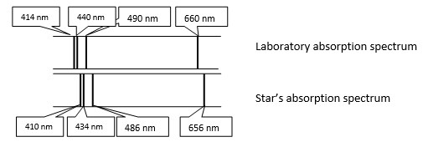

1. Name this phenomenon observed with stars where the wavelength of spectral lines changes (1 mark)

______________________________________________

1. Explain how this observed effect comes about (3 marks)

________________________________________________________________________  
  
________________________________________________________________________

________________________________________________________________________  
  
________________________________________________________________________

________________________________________________________________________  
  
________________________________________________________________________

________________________________________________________________________  
  
________________________________________________________________________

1. What data can be obtained from the change in wavelength of light emitted from stars. (1 mark)

________________________________________________________________________  
  
________________________________________________________________________

**Question 4 (4 marks)**

Complete the table below regarding fundamental forces and their field particles.

|  |  |
| --- | --- |
| **Interactions** | **Field Particle** |
| Weak |  |
|  | Graviton |
|  | Gluon |
| Electromagnetic |  |

**Question 5 (3 marks)**

Consider a proton with energy 4TeV in the Large Hadron Collider.

1. What is the energy of this particle in joules? (1mark)

**_____________________ J**

1. How fast would a mosquito, with a mass of about 3mg, need to fly to have the same kinetic energy? (2 marks)

**_____________________ m s-1**

**Section Two:** Extended answer

**Question 1 (16 marks)**

An electron is accelerated to 0.998c before it enters a region of space and follows a path that has a constant radius of 0.348m while in the magnetic field shown on the diagram, before striking a target anode.



a) on the diagram show that the magnetic field is into the page (1 mark)

b) Derive the formula $B= \frac{mv}{qr}$ (2 marks)

c) Use this formula to calculate the field strength needed to direct the electron along this path. Express your *answer to 3 significant figures and include the units.*  (5 marks)

d) Describe how each of the changes below affect the charged particle’s path in the magnetic field.

(4 marks)

|  |  |
| --- | --- |
| **Property change** | **Effect on radius of path** |
| Particle charge is reversed |  |
| Particle charge is increased |  |
| Particle velocity is increased |  |
| Magnetic field strength is increased |  |

e) Relativistic effects were not considered when calculating the electron’s path. Outline briefly the effects that special relativity predicts about the radius of the electron’s motion.

(2 marks)

__________________________________________________________________________________________

__________________________________________________________________________________________

__________________________________________________________________________________________

__________________________________________________________________________________________

f) Find the total energy of the electron after the acceleration. (3 marks)

________________ J

**Question 2 (7 marks)**

A particular baryon consists of two up quarks and a strange quark.  
  
a) Determine the charge and baryon number for this baryon (2 marks)

Charge _________

Baryon number _____________

b) A neutron will decay into a proton and an electron as shown in the equation below.  
  
  
 n 🡪 p+ + e- + ?

1. Demonstrate that the baryon number is preserved in the way that the equation is written  
    (1 mark)
2. Demonstrate that the lepton number is not conserved. (1 mark)
3. Identify the third particle in the decay to ensure that the lepton number is conserved. (1 mark)

c) Identify **one** type of gauge boson and describe its role in the nucleus (2 marks)

**Section Three:** Comprehension and data analysis

The Doppler shift in the wavelength of light emitted by galaxies can be used to measure the speed with which they are moving towards or away from the Earth.

Like the Sun, galaxies emit a wide range of wavelengths. The analysis of the absorption spectra of light from galaxies can have two spectral lines missing due to the absorption by calcium ions as light passes through the gases surrounding galaxies.

In the constellation Eridanus which is visible in the western sky between January to April there is a spiral galaxy NGC 1357. The wavelength of one of the calcium absorption lines in the spectrum from NGC 1357 is 399.72 nm. The same line in the calcium spectrum measured in a laboratory on Earth is 396.85 nm.

1. Is the spiral galaxy NGC 1357 moving towards or away from the Earth?

(1 mark)

1. Justify your answer to (a) using a brief explanation and a diagram.

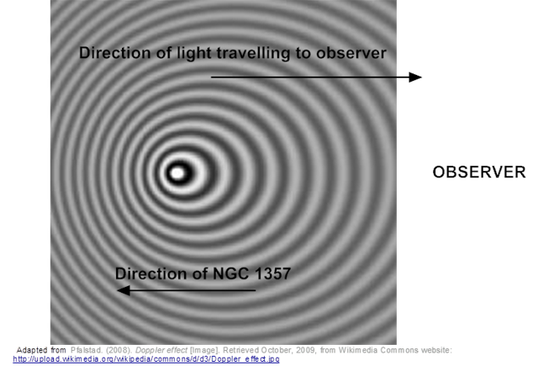

(4 marks)

________________________________________________________________________  
  
________________________________________________________________________

________________________________________________________________________  
  
________________________________________________________________________

________________________________________________________________________  
  
________________________________________________________________________

________________________________________________________________________  
  
________________________________________________________________________

1. Calculate the velocity of NGC 1357 using the relationship $\frac{∆λ}{λ_{rest}}=\frac{v}{c}$

Where $Δλ=λ_{shifted}-λ_{rest}$

and λrest is the wavelength of the fixed source, v is the speed of the moving source and c is the speed of light.

(2 marks)  
  
  
  
  
  
  
  
  
  
  
  
  
  
  
  
  
  
_________________m s-1

1. A star has a recessional velocity of 58.9 km s-1. Calculate the ‘red shift’ that would be expected in the calcium 396.849 nm absorption line from this star.

Use the relationship

$$\frac{∆λ}{λ_{rest}}=\frac{v}{c}$$

Where, Δλ is the change in wavelength, λrest is the wavelength of the fixed source, v is the speed of the moving source and c is the speed of light.

(2 marks)

___________________ m

**End of Test**